# Integrating One to One chat

## UI Changes required:

While getting the message from the Server we are only showing

{inMessage}

Code snippet :

render(){

const{inMessage} = this.state

if( inMessage != ''){

return(

<div style={{width: '100%'}}>

{inMessage}

</div>

)

}

return null

}

Now we need to handle the emitted message from server and get the username as well as the message and show in the screen.

We can create one more function for getting the emitted message

socket.on('new message',function(data){

})

## Server side changes:

We need to emit the message from the server with the message and the username so that any handler on the client can take that event and show it on the screen.

io.sockets.emit('message',{msg:data, user:socket.username});

Errors encountered while trying to save the UI changes :

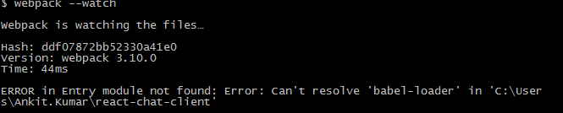

After installing

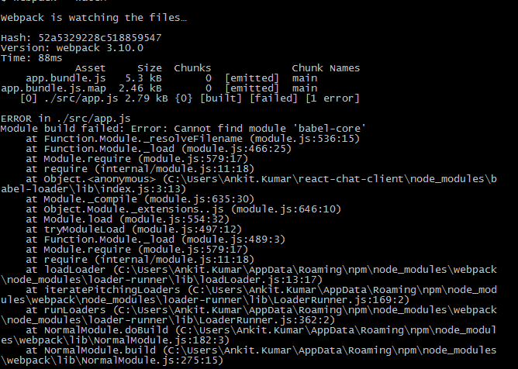

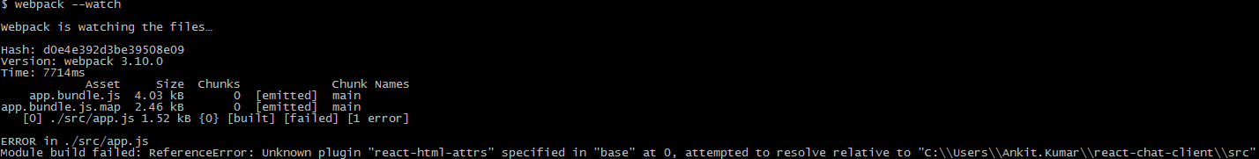

So finally not able to compile the changes for the UI in order to test the One to One functionality.